長庚大學102學年度第一學期作業系統第期末測驗(總分106)

系級: 姓名: 學號:

1. (15%) There are four necessary conditions to form the deadlock problem. One is **Mutual Exclusion**, and the meaning of Mutual Exclusion is that only one process at a time can use a resource. Please list the remaining three conditions and explain their meaning.

Answer:

* **Hold and Wait:** a process holding at least one resource is waiting to acquire additional resources held by other processes.(5%)
* **No Preemption:** a resource can be released only voluntarily by the process holding it. (5%)
* **Circular Wait:** there exists a set {*P*0, *P*1, …, *P*n-1} of waiting processes such that each *P*i is waiting for a resource that is held by *P*(i+1)%n) (5%)

2. (12%) Please define what are (1) Deadlock Prevention and (2) Deadlock Avoidance

Answer:

Deadlock Prevention is to fail anyone of the necessary conditions of the deadlock problem. (6%)

Deadlock Avoidance is to dynamically examine the resource-allocation state to ensure that there can never be a circular-wait condition. This is, the system is in a safe state. (6%)

3. (18%) Banker’s Algorithm is a deadlock avoidance algorithm. Assume there are 5 processes {P0, P1, P2, P3, P4} and three types of shared resources {A, B, C} in the system, and the details are in the following table. (1) By Banker’s Algorithm, is the system in a safe state? If your answer is yes, please provide a safe sequence. If your answer is no, please provide the reason. (2) Now, P0 further has a request (3, 2 , 1) to use 3 more instance of type A, 2 more instances of type B and 1 more instance of type C. Should the request be granted? If your answer is yes, please provide a safe sequence after the request is granted. If your answer is no, please provide the reason.

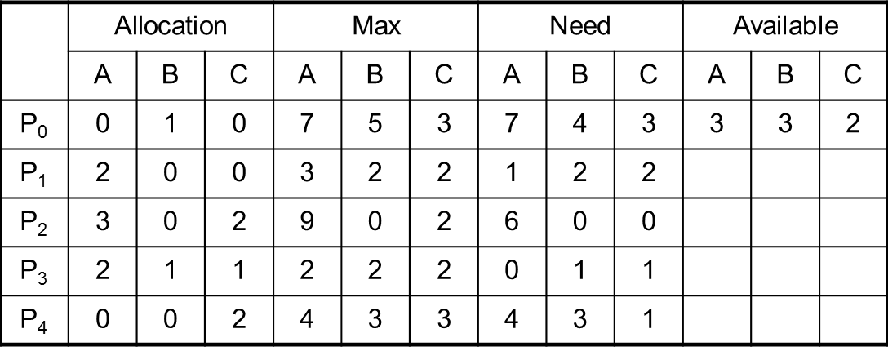

Process Burst Time

P1 10

P2 1

P3 2

P4 3

P5 5

Answer:

(1) Yes, <P1,P3,P4,P0,P2> is a safe sequence with the available resources (3,3,2)🡪 (5,3,2)🡪 (7,4,3)🡪 (7,4,5)🡪 (7,5,5). (9%)

(2) Yes, there are two reasons: I. (3 ,2 ,1) < (7,4,3) II. After the request is granted, <P3,P1,P0,P2,P4> is a safe sequence with the available resources (0,1,1)🡪(2,2,2)🡪(4,2,2)🡪(7,5,3)🡪(10,5,5).

Note that: after the request is granted, for P0, the allocated resources are (3,3,1), the maximum resources are (7,5,3), and the needed resources are (4,2,2) . (9%)

4. (12%) For memory management, please define (1) External Fragmentation and (2) Internal Fragmentation.

Answer:

* **External Fragmentation:** total memory space exists to satisfy a request, but it is not contiguous. (6%)
* **Internal Fragmentation:** allocated memory may be slightly larger than requested memory; this size difference is memory internal to a partition, but not being used. (6%)

5. (18%) This question is to evaluate your knowledge of paging. For a system with a page table and a TLB, as shown in the following figure, please (1) define what is TLB. (2) Please explain the meaning of the numbers p, d and f in the figure.

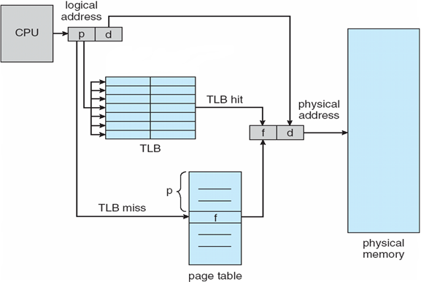

Answer:

(1) TLB is the cache of page table. It is a kind of SRAM with short access latency and is used to reduce the time for reading data from the page table. (6%)

(2) p is the page number which points to a page in the logical address of the process. (4%) d is the offset which points out the location of the to-be-accessed data in the page. (4%) f is the frame number which identifies the location in the physical memory for the page. (4%)

6. (16%) There is system with only 3 memory frames. Given a reference string of pages {7🡪0🡪1🡪2🡪0🡪3🡪0🡪4🡪2🡪4🡪0🡪3🡪7}, please illustrate the page replacement of (1) FIFO algorithm and (2) LRU algorithm.

Answer:

(1) (8%)

|  |  |  |  |  |  |  |  |  |  |  |  |  |
| --- | --- | --- | --- | --- | --- | --- | --- | --- | --- | --- | --- | --- |
| 7 | 7 | 7 | 2 | 2 | 2 | 2 | 4 | 4 | 4 | 4 | 4 | 7  🡨 The pages in the three frames |
|  | 0 | 0 | 0 | 0 | 3 | 3 | 3 | 2 | 2 | 2 | 2 | 2 |
|  |  | 1 | 1 | 1 | 1 | 0 | 0 | 0 | 0 | 0 | 3 | 3 |
|  | | | | | | | | | | | | |
| 7 | 0 | 1 | 2 | 2 | 3 | 0 | 4 | 2 | 2 | 2 | 3 | 7 |
|  | 7 | 0 | 1 | 1 | 2 | 3 | 0 | 4 | 4 | 4 | 2 | 3  🡨 The victim is here |
|  |  | 7 | 0 | 0 | 1 | 2 | 3 | 0 | 0 | 0 | 4 | 2 |

(2) (8%)

|  |  |  |  |  |  |  |  |  |  |  |  |  |
| --- | --- | --- | --- | --- | --- | --- | --- | --- | --- | --- | --- | --- |
| 7 | 7 | 7 | 2 | 2 | 2 | 2 | 4 | 4 | 4 | 4 | 4 | 7  🡨 The pages in the three frames |
|  | 0 | 0 | 0 | 0 | 0 | 0 | 0 | 0 | 0 | 0 | 0 | 0 |
|  |  | 1 | 1 | 1 | 3 | 3 | 3 | 2 | 2 | 2 | 3 | 3 |
|  | | | | | | | | | | | | |
| 7 | 0 | 1 | 2 | 0 | 3 | 0 | 4 | 2 | 4 | 0 | 3 | 7 |
|  | 7 | 0 | 1 | 2 | 0 | 3 | 0 | 4 | 2 | 4 | 0 | 3  🡨 The victim is here |
|  |  | 7 | 0 | 1 | 2 | 2 | 3 | 0 | 0 | 2 | 4 | 0 |

7. (15%) (1) What is the benefit for increasing the degree of multiprogramming of a multi-core system? (2) Please define “Trashing.” (3) How can we detect that a system is in a trashing state?

Answer:

(1) Increasing the degree of multiprogramming has the potential for improving the utilization of multiple cores. (5%)

(2) The system is busy swapping pages in and out. (5%)

(3) Watch the rate of page faults. If the rate increases rapidly when the degree of multiprogramming increases, it might be in a trashing state. (5%)